# Problem 5 – Salaries

We have a classical **hierarchy** between the employees in a company. The big boss manages directly several people, they manage other people, etc. The people who manage nobody are called **regular employees** and their salaries are **1**. People who manage at least one employee are called **managers**. Each manager takes a salary which is equal to the sum of the salaries of their directly managed employees. Managers cannot manage directly or indirectly (transitively) themselves. See a sample hierarchy in a company along with the salaries computed following the above described rule:

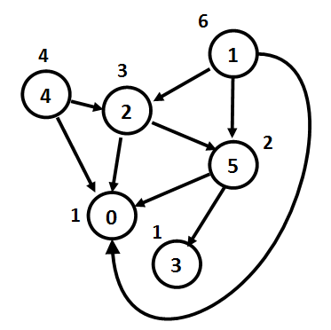

If we have **N** employees, they will be indexed from 0 to N – 1. For each employee, you’ll be given a string with N symbols. The symbol at a given index **i**, either **'Y' or 'N'**, shows whether the current employee is a direct manager of employee **i**.

**Hint**: find the node with no parent and start a **DFS traversal** from it to calculate the salaries on the tree recursively.

### Input

* The input data should be read from the console.
* On the first line you’ll be given an integer N.
* On the next N lines you’ll be given strings with N symbols (either 'Y' or 'N').
* The input data will always be valid and in the format described. There is no need to check it explicitly.

### Output

* The output should be printed on the console. It should consist of one line:
* On the only output line print the sum of the salaries of all employees.

### Constraints

* N will be an integer in the range [1 … 50].
* For each i-th line, the i-th symbol will be 'N'.
* If employee A is the manager of employee B, B will not be a manager of A.
* Allowed working time for your program: 0.1 seconds. Allowed memory: 16 MB.

### Examples

|  |  |  |
| --- | --- | --- |
| **Input** | **Output** | **Comments** |
| 1  N | 1 | Only 1 employee with salary 1. |
| 4  NNYN  NNYN  NNNN  NYYN | 5 | We have 4 employees. 0, 1, and 3 are managers of 2. 3 is also a manager of 1. Therefore:  salary(2) = 1  salary(0) = salary(2) = 1  salary(1) = salary(2) = 1  salary(3) = salary(2) + salary(1) = 2 |
| 6  NNNNNN  YNYNNY  YNNNNY  NNNNNN  YNYNNN  YNNYNN | 17 |  |